Question 01.

package Question01;

public class **Test** {

public static void main(String[] args) {

Functions functions = new Functions();

functions.addElement();

functions.view();

}

}

package Question01;

public class **Functions** {

List numberList = new List(6);

void addElement(){

numberList.insertLast(new Number(0, new int[]{0}));

numberList.insertLast(new Number(1, new int[]{0, 2, 2, 4}));

numberList.insertLast(new Number(2, new int[]{5}));

numberList.insertLast(new Number(6, new int[]{5}));

numberList.insertLast(new Number(7, new int[]{1, 8}));

numberList.insertLast(new Number(8, new int[]{6}));

}

void view(){

for (int i = 0; i < numberList.listSize(); i++) {

System.out.println(numberList.retrieveListData(i));

}

}

}

package Question01;

public class **List** {

private int maxSize;

private int position;

private Number[] listEntry;

public List(int size) {

maxSize = size;

listEntry = new Number[maxSize];

position = -1;

}

public boolean isListEmpty() {

return (position == -1);

}

public boolean isListFull() {

return (position == maxSize - 1);

}

public int listSize() {

return (position + 1);

}

public void insertLast(Number x) {

if (isListFull()) {

System.out.println("Error: Attempt to insert at the end of a full list");

} else {

listEntry[++position] = x;

}

}

public void insertList(int p, Number element) {

if (isListFull()) {

System.out.println("Error: Attempt to insert an entry into a full list");

} else if (p < 0 || p > listSize()) {

System.out.println("Error: Attempt to insert at position " + p + " which is out of bounds [0, " + listSize() + "]");

} else {

for (int i = listSize(); i > p; i--) {

listEntry[i] = listEntry[i - 1];

}

listEntry[p] = element;

position++;

}

}

public Number deleteList(int p) {

Number element;

if (isListEmpty()) {

System.out.println("Error: Attempt to delete an entry from an empty list");

return null;

} else if (p < 0 || p >= listSize()) {

System.out.println("Error: Attempt to delete position " + p + " which is not in the list [0, " + (listSize() - 1) + "]");

return null;

} else {

element = listEntry[p];

for (int i = p; i < listSize() - 1; i++) {

listEntry[i] = listEntry[i + 1];

}

position--;

return element;

}

}

public Number retrieveList(int p) {

if (isListEmpty()) {

System.out.println("Error: Attempt to retrieve an entry from an empty list");

return null;

} else if (p < 0 || p >= listSize()) {

System.out.println("Error: Attempt to retrieve entry at position " + p + " which is not in the list [0, " + (listSize() - 1) + "]");

return null;

} else {

return listEntry[p];

}

}

public void replaceList(int p, Number x) {

if (isListEmpty()) {

System.out.println("Error: Attempt to replace an entry of an empty list");

} else if (p < 0 || p >= listSize()) {

System.out.println("Error: Attempt to replace entry at position " + p + " which is not in the list [0, " + (listSize() - 1) + "]");

} else {

listEntry[p] = x;

}

}

public void traverseList() {

if (isListEmpty()) {

System.out.println("List is empty.");

return;

}

System.out.print("List: [");

for (int i = 0; i < listSize(); i++) {

System.out.print(listEntry[i]);

if (i < listSize() - 1) {

System.out.print(", ");

}

}

System.out.println("]");

}

public void clearList() {

position = -1;

}

public int[] getInternalArrayCopy() {

if (isListEmpty()) {

return new int[0];

}

int[] copy = new int[listSize()];

System.arraycopy(listEntry, 0, copy, 0, listSize());

return copy;

}

public String retrieveListData(int p) {

if (isListEmpty()) {

System.out.println("Error: Attempt to retrieve an entry from an empty list");

} else if (p < 0 || p >= listSize()) {

System.out.println("Error: Attempt to retrieve entry at position " + p + " which is not in the list [0, " + (listSize() - 1) + "]");

} else {

return listEntry[p].viewNumbers();

}

return null;

}

}

package Question01;

public class **Number** {

int stem;

int[] leaves;

public Number(int stem, int[] leaves) {

this.stem = stem;

this.leaves = leaves;

}

String viewNumbers(){

for (int leaf:leaves ) {

System.out.print(stem + ""+leaf + " ");

}

return " ";

}

}

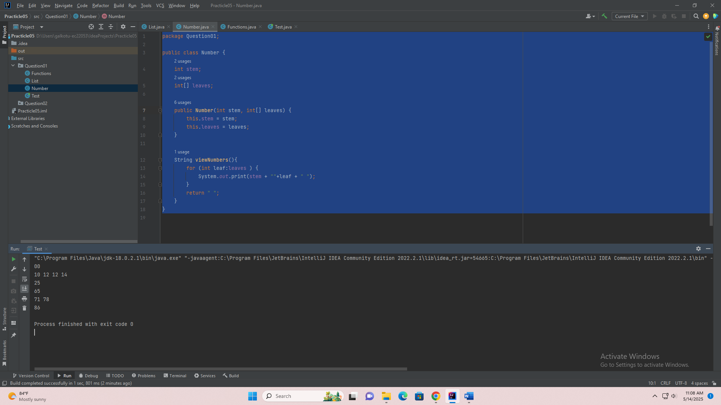

s

Question 02.

package Question02;

public class **Test** {

public static void main(String[] args) {

Functions function = new Functions();

function.addData();

function.bestProductOfRgionNorth();

function.bestProductOfRgionEast();

function.bestProductOfRgionSouth();

function.bestofQuarter();

}

}

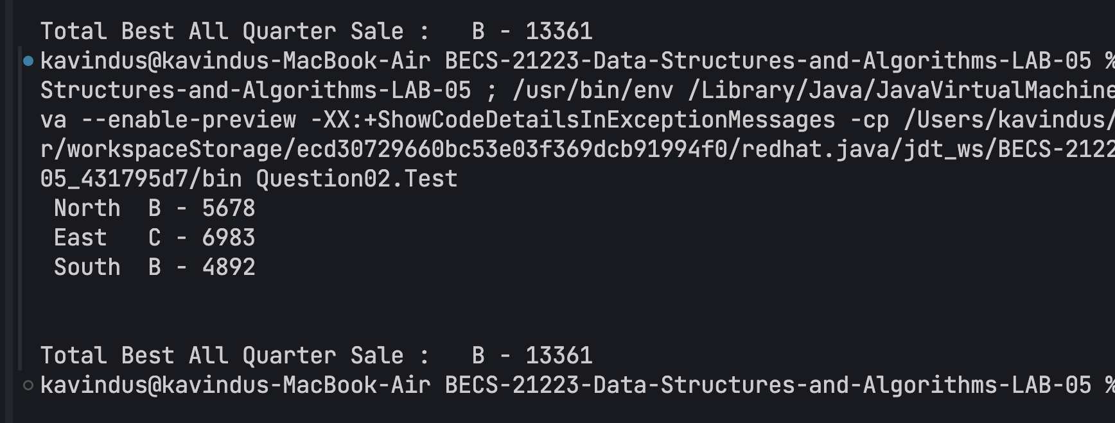

package Question02;

public class **Products** {

String name;

int north;

int south;

int east;

int totalSales;

public Products(String name, int north, int south, int east) {

this.name = name;

this.north = north;

this.south = south;

this.east = east;

this.totalSales = north + east +south;

}

}

package Question02;

public class **List** {

private int maxSize;

private int position;

private Products[] listEntry;

public List(int size) {

maxSize = size;

listEntry = new Products[maxSize];

position = -1;

}

public boolean isListEmpty() {

return (position == -1);

}

public boolean isListFull() {

return (position == maxSize - 1);

}

public int listSize() {

return (position + 1);

}

public void insertLast(Products x) {

if (isListFull()) {

System.out.println("Error: Attempt to insert at the end of a full list");

} else {

listEntry[++position] = x;

}}

public void insertList(int p, Products element) {

if (isListFull()) {

System.out.println("Error: Attempt to insert an entry into a full list");

} else if (p < 0 || p > listSize()) {

System.out.println("Error: Attempt to insert at position " + p + " which is out of bounds [0, " + listSize() + "]");

} else {

for (int i = listSize(); i > p; i--) {

listEntry[i] = listEntry[i - 1];

}

listEntry[p] = element;

position++;

}

}

public Products deleteList(int p) {

Products element;

if (isListEmpty()) {

System.out.println("Error: Attempt to delete an entry from an empty list");

return null;

} else if (p < 0 || p >= listSize()) {

System.out.println("Error: Attempt to delete position " + p + " which is not in the list [0, " + (listSize() - 1) + "]");

return null;

} else {

element = listEntry[p];

for (int i = p; i < listSize() - 1; i++) {

listEntry[i] = listEntry[i + 1];

}

position--;

return element;

}}

public Products retrieveList(int p) {

if (isListEmpty()) {

System.out.println("Error: Attempt to retrieve an entry from an empty list");

return null;

} else if (p < 0 || p >= listSize()) {

System.out.println("Error: Attempt to retrieve entry at position " + p + " which is not in the list [0, " + (listSize() - 1) + "]");

return null;

} else {

return listEntry[p];

}

}

public void replaceList(int p, Products x) {

if (isListEmpty()) {

System.out.println("Error: Attempt to replace an entry of an empty list");

} else if (p < 0 || p >= listSize()) {

System.out.println("Error: Attempt to replace entry at position " + p + " which is not in the list [0, " + (listSize() - 1) + "]");

} else {

listEntry[p] = x;

}

}

public void traverseList() {

if (isListEmpty()) {

System.out.println("List is empty.");

return;

}

System.out.print("List: [");

for (int i = 0; i < listSize(); i++) {

System.out.print(listEntry[i]);

if (i < listSize() - 1) {

System.out.print(", ");

}

}

System.out.println("]");

}

public void clearList() {

position = -1;

}

public int[] getInternalArrayCopy() {

if (isListEmpty()) {

return new int[0];

}

int[] copy = new int[listSize()];

System.arraycopy(listEntry, 0, copy, 0, listSize());

return copy;

}

public String retrieveListData(int p) {

if (isListEmpty()) {

System.out.println("Error: Attempt to retrieve an entry from an empty list");

} else if (p < 0 || p >= listSize()) {

System.out.println("Error: Attempt to retrieve entry at position " + p + " which is not in the list [0, " + (listSize() - 1) + "]");

} else {

return listEntry[p].name;

}

return null;

}

}

package Question02;

public class **Functions** {

List list = new List(4);

void addData(){

Products productA = new Products("A", 1450, 467, 3800);

Products productB = new Products("B", 5678, 4892, 2791);

Products productC = new Products("C", 2987, 270, 6983);

Products productD = new Products("D", 829, 1500, 29);

list.insertLast(productA);

list.insertLast(productB);

list.insertLast(productC);

list.insertLast(productD);

}

String bestProductOfRgionNorth(){

String productName = null;

int initia = 0;

for (int i = 0; i < 4; i++) {

if (list.retrieveList(i).north > initia){

initia = list.retrieveList(i).north;

productName = list.retrieveListData(i);

}

}

System.out.println(" North \t" +productName+" - " + initia);

return productName;

}

String bestProductOfRgionSouth(){

String productName = null;

int initia = 0;

for (int i = 0; i < 4; i++) {

if (list.retrieveList(i).south > initia){

initia = list.retrieveList(i).south;

productName = list.retrieveListData(i);

}

}

System.out.println(" South \t" +productName + " - " + initia);

return productName;

}

String bestProductOfRgionEast(){

String productName = null;

int initia = 0;

for (int i = 0; i < 4; i++) {

if (list.retrieveList(i).east > initia){

initia = list.retrieveList(i).east;

productName = list.retrieveListData(i);

}

}

System.out.println(" East \t" +productName+" - " + initia);

return productName;

}

String bestofQuarter(){

String productName = null;

int initia = 0;

for (int i = 0; i < 4; i++) {

if (list.retrieveList(i).totalSales > initia){

initia = list.retrieveList(i).totalSales;

productName = list.retrieveListData(i);

}

}

System.out.println(" \n\nTotal Best All Quarter Sale :\t" +productName+" - " + initia);

return productName;

}

}